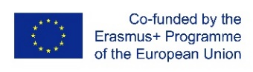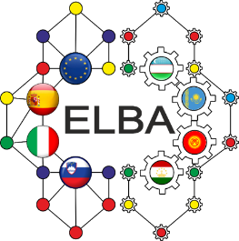
Round table “Dissemination of information about projects under the Erasmus + program:
capacity building, impact and expansion of partnership "
(within the framework of ELBA project
“Establishment of training and research centers and Courses development on Intelligent BigData Analysis in CA”)

Round table program
Date - October 15, 2020
Time - 02 PM - 04:00 PM (time of Nur-Sultan).
Target group - project teams of partner universities, top managers of universities
The format - online, ZOOM platform.
Connection link:
Topic: Global Erasmus+ Day
Time: Oct 15, 2020 02:00 PM Almaty
Join Zoom Meeting
https://us02web.zoom.us/j/86994800997?pwd=RFpvSkk1eGFPRVdvcUc0TXkvRXRTdz09
Meeting ID: 869 9480 0997
Passcode: 151020

14.00-14.15 | Welcome:  - Daineko Yevgeniya, Vice rector for International Cooperation, IITU  - Yelena Kandalina, country coordinator, ABKRU  - Losada Carril David Enrique, Professor, Universidade de Santiago de Compostela, Испания  - Emilio Musso, Professor, Tutin Politechnic University, Italy  Moderator: A. Sarsembayev, assoc. prof IITU
14.15-14.35 | “Data Science track for a future data scientist: case study”  - Sarsembayev, Yergali Dauletbek - IITU
14.35-15.50 | «Data Science: EU university experience»  Losada Carril David Enrique, Professor, Universidade de Santiago de Compostela, Испания  - Emilio Musso, Professor, Turin Politechnic University, Italy  - Sara Scaramuccia, Professor  Discussion: participants – team members of Akhmet Baitursynov Kostanay Regional University, International Information Technology University
15.50-16.00 | Conclusion:  - Yelena Kandalina, country coordinator, Assoc. prof ABKRU  - Gulnara Zakirova, IITU Coordinator, Assoc. prof

