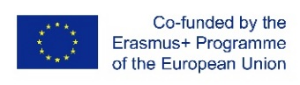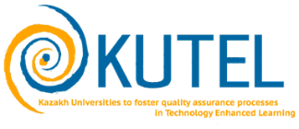
Round table “Dissemination of information about projects under the Erasmus + program:
capacity building, impact and expansion of partnership "
(within the framework of the KUTEL project
“Kazakh Universities to foster quality assurance processes in Technology Enhanced Learning”)

Round table program
Date - October 15, 2020
Time - 02 PM - 04:00 PM (time of Nur-Sultan).
Target group - project teams of partner universities, top managers of universities
The format - online, ZOOM platform.
Connection link:
Topic: Global Erasmus+ Day
Time: Oct 15, 2020 02:00 PM Almaty
Join Zoom Meeting
https://us02web.zoom.us/j/86994800997?pwd=RFpvSkk1eGFPRVdvcUc0TXkvRXRTdz09
Meeting ID: 869 9480 0997
Passcode: 151020

14.00-14.15 | Welcome:  - Daineko Yevgeniya, Vice rector for International Cooperation, IITU  - Matteo Martini, USGM, Università degli Studi Guglielmo Marconi, Italy  Moderator: Nurzhan Duzbayev, Vice-rector for Digitalization and innovation, IITU, Assoc. prof
14.15-14.20 | Video film – KUTEL: Erasmus+ project for TEL.
14.20-14.50 | “Quod non fecit COVID fecerunt Athenaea”  (TEL, Covid pandemic, e-learning and how the traditional universities responded to COVID respect to an online university)  Prof. Matteo Martini, USGM, Università degli Studi Guglielmo Marconi, Italy
14.50-15.50 | Discussion: Topical issues of TEL education in modernization and enhancement of educational programs and courses.  - Aissulu Shayakhmetova – Associate Prof, Sh. Ualikhanov Kokshetau State University.  - Lyazzat Karimova – Assoc. Prof, Abay Myrzakhmetov Kokshetau University  - Natalya Kific – Assoc. Prof Akhmet Baitursynov Kostanay Regional University.
15.50-16.00 | Conclusion:  - Gulnara Zakirova, Country Coordinator, Assoc. Prof (Almaty, RK)

